Companion Mirror Installation Guide
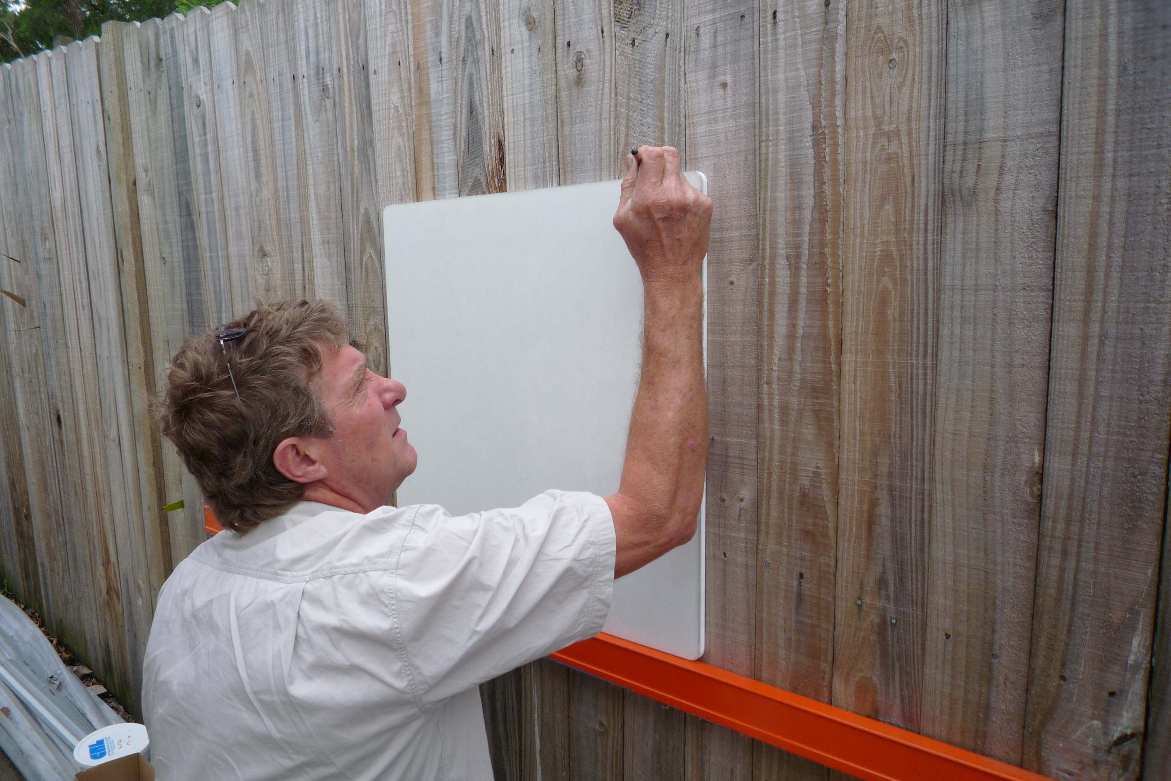
Checklist of components
2 x stationery clips
2 x Male/female adjustable clips
Screws to suit
Silicone adhesive

Step 1
Place mirror in desired location
Check for level and mark-out wall
If necessary add packing to create
Level surface

Step 2

Fix Stationery clip on LHS and Underside
Male Female clips on top and opposing side.
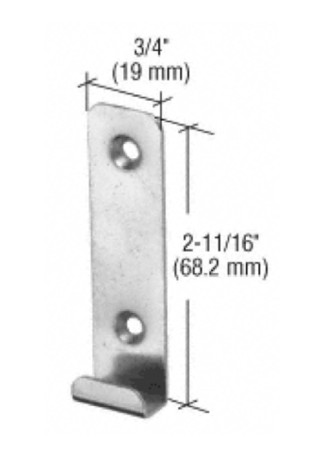
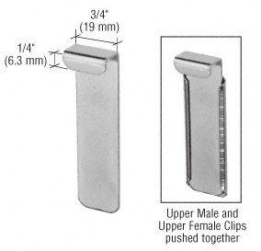

Screw mirror clips in place and add small amounts of supplied silicon.

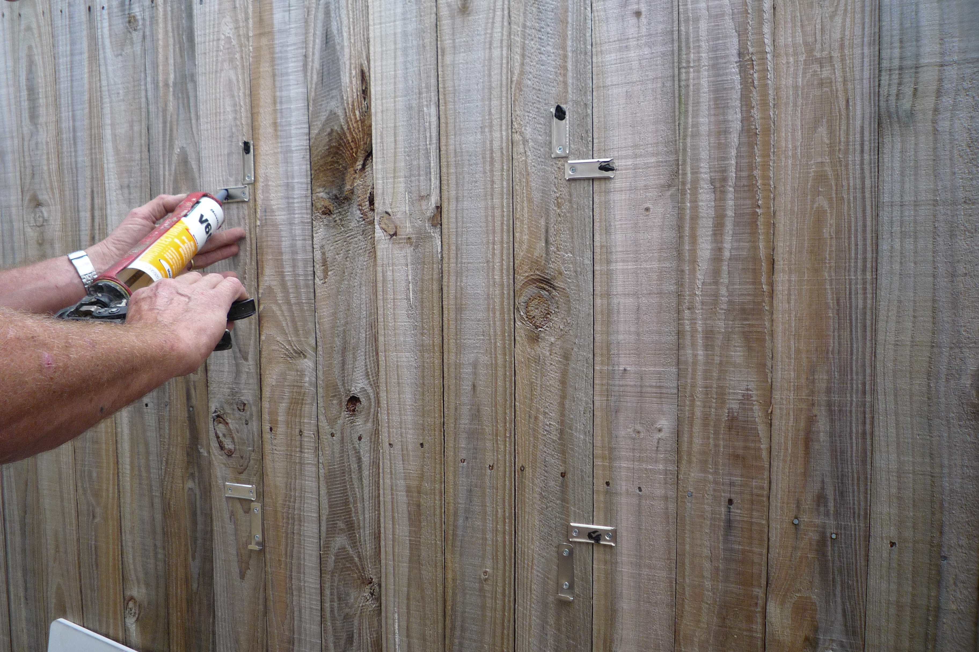

Step Three

Push the mirror onto the Stationery clips and into the slots in the mirror backing
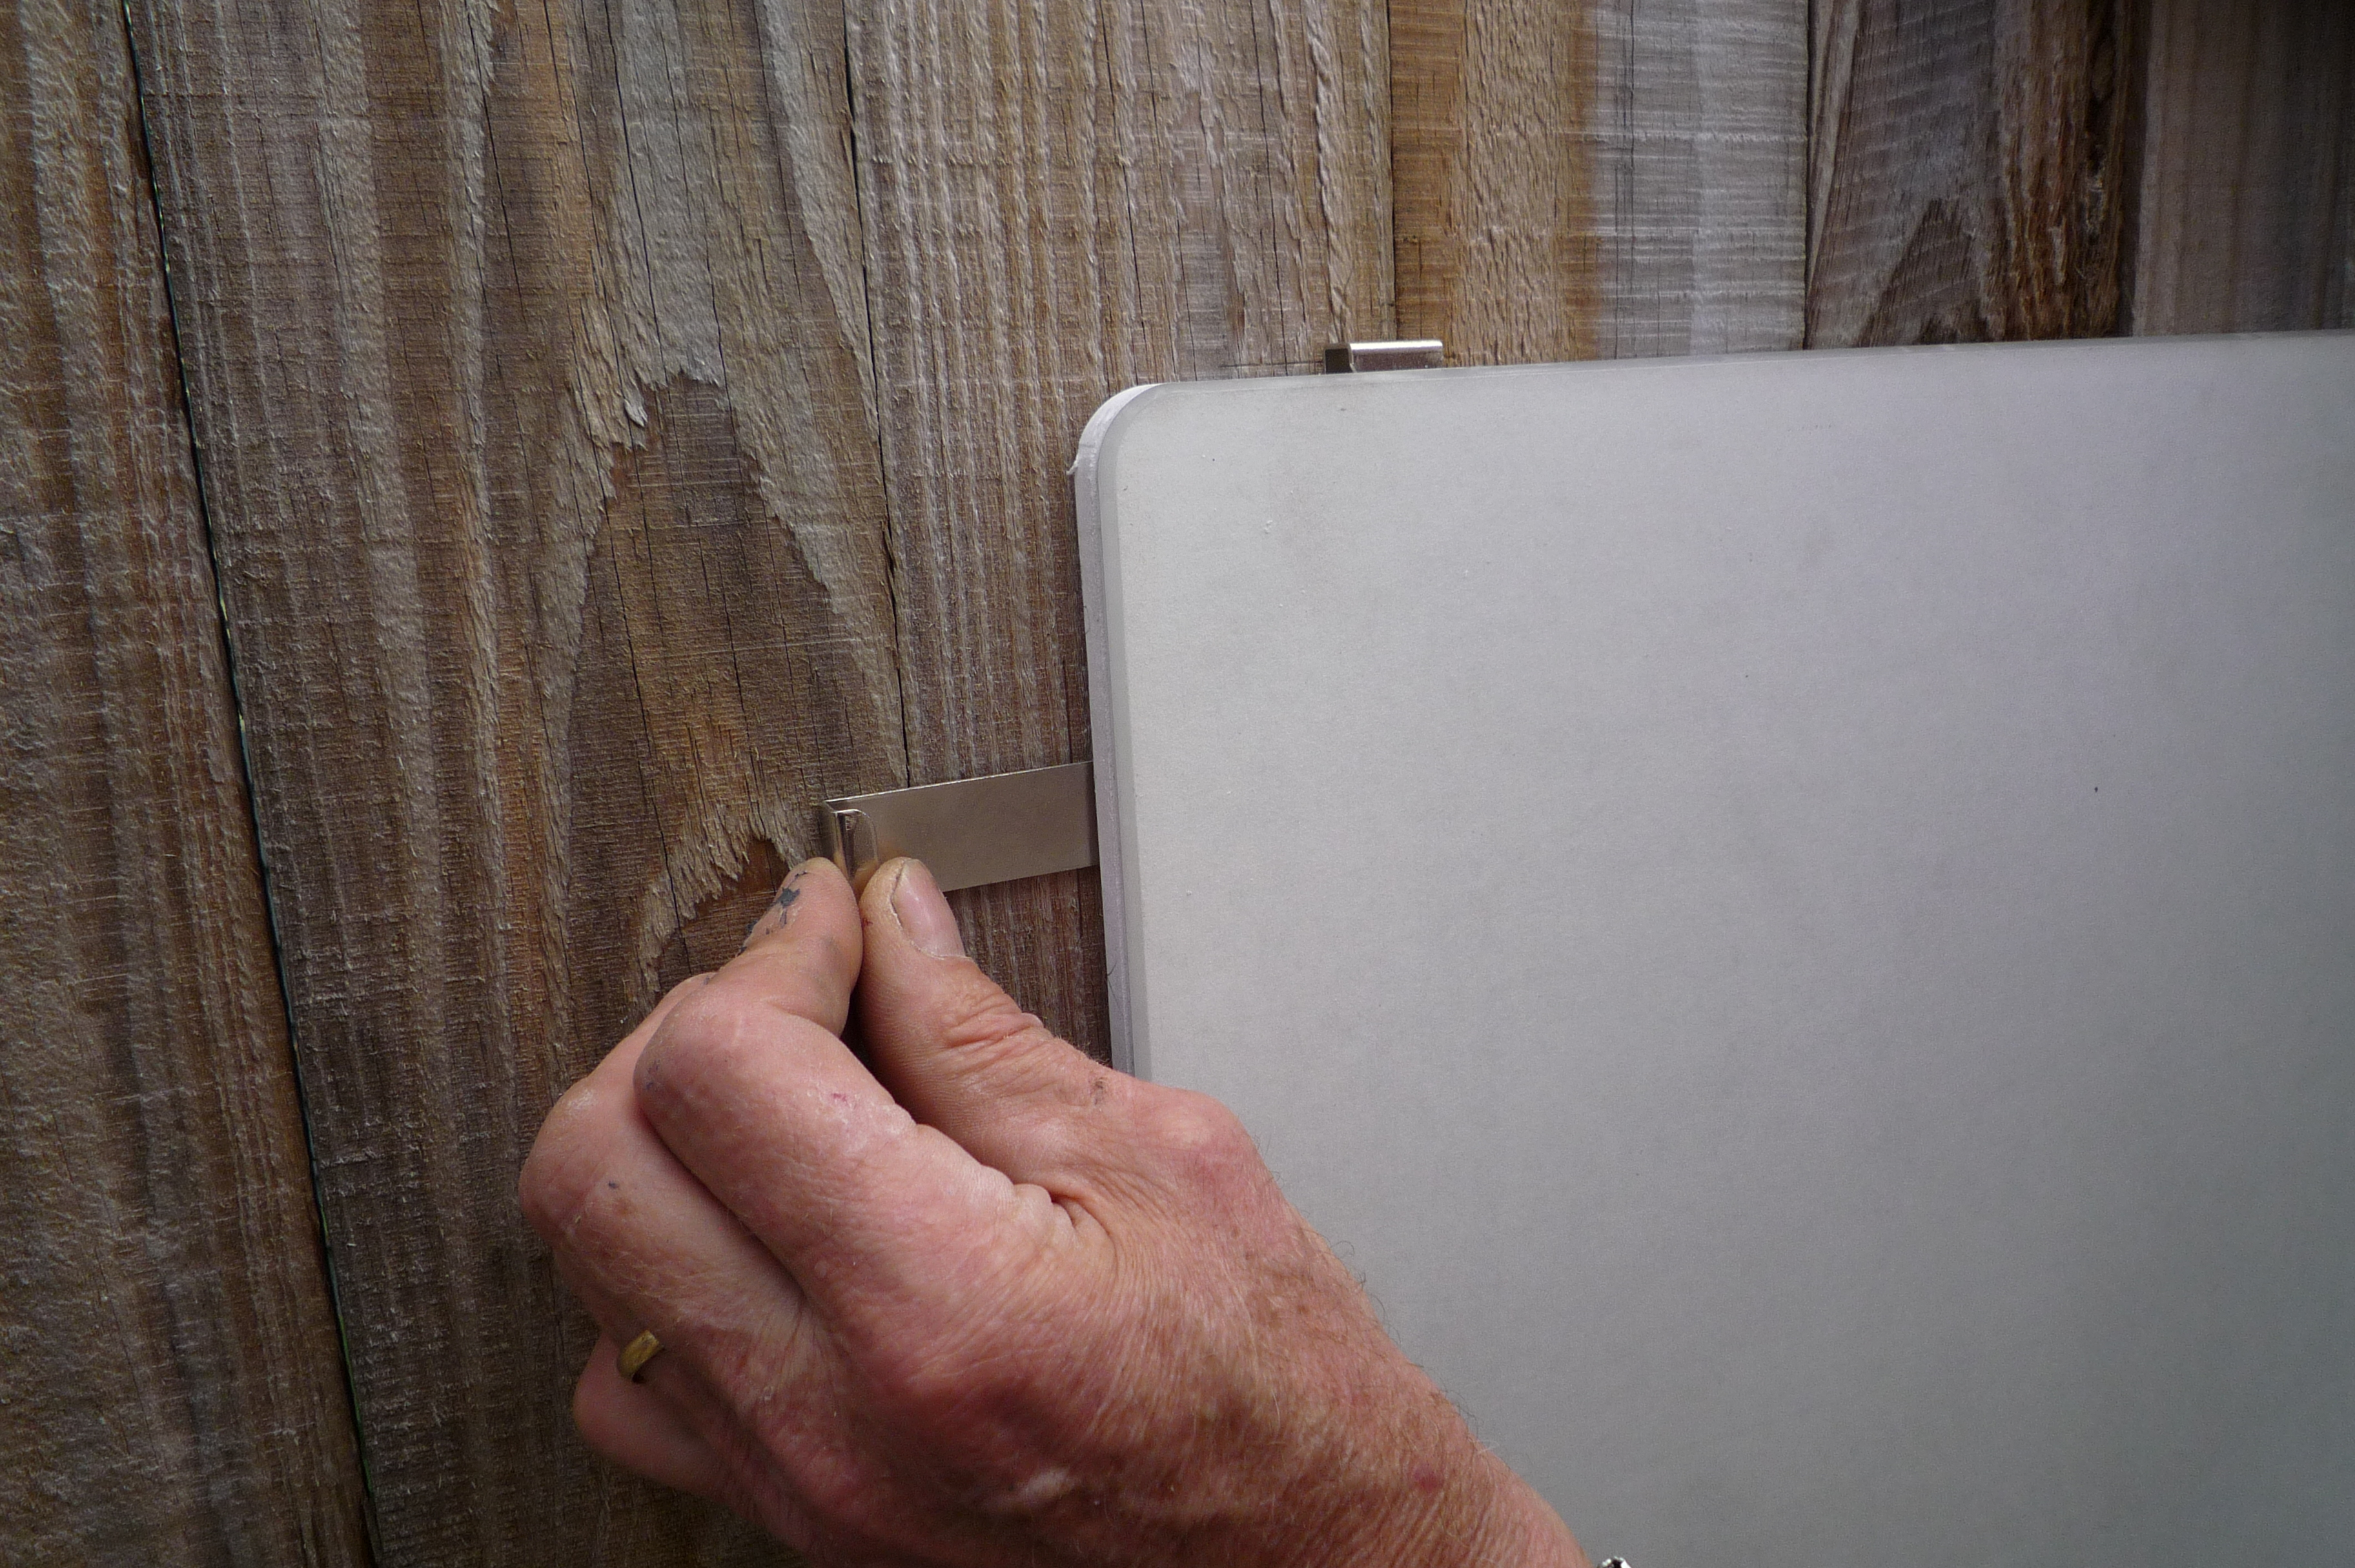

Step Four

Push upper and side male clips together into receivers and into slots in the side of PVC backing.

Step Five

Remove protective paper from mirror surface.

Step Six

Enjoy!!

